ISM 6208: Data Warehousing


Group – 8
Naga Pavan Sathvik Reddy Sirigiri
Aravind Polavarapu
Mohammad Sahil
GLOBAL HELTH BURDEN OF AIR POLLUTION

Contents
1. Executive Summary 2
2. Problem Statement 3
3. Literature Review 4
4. Data Collection and Preparation 4
4.1 Data Sources 4
4.2 Data Cleaning and Processing 5
4.3-Dimensional Modeling 7
5. Data Warehouse Design and Implementation 15
6. Connect Tableau to PostgreSQL 21
7. Story Telling - Data Analysis 22
8. Key Findings 29
9. Conclusion 30
10. Next Steps and Recommendations 30
11. References 31

Executive Summary
Air pollution is a serious global health hazard, with fine particulate matter (PM2.5) accounting for a significant proportion of premature deaths globally. This project develops a small but comprehensive data-warehouse-based analytics solution to quantify the global health impact of air pollution, with a focus on PM2.5 concentrations, air pollution-related mortality, and key socioeconomic drivers such as industrialization, urbanization, and population density.
The project uses numerous worldwide datasets, a PostgreSQL data warehouse, Python-based ETL scripts, and Tableau dashboards to answer five key research questions about trends, spatial inequalities, and drivers of pollution-related death. The data warehouse is structured as a star schema, with a single fact table (fact_air_pollution_burden) at the country-year level and two core dimensions (dim_date and dim_location). Raw CSV files are initially put into a staging schema, which is then turned into clean, integrated analytical tables using Python ETL scripts.
database_creation_python_script
push_to_postgres_python_script
The Tableau dashboards and article indicate that while global PM2.5 and air-pollution-related mortality have decreased over the past 30 years, many countries still have levels that exceed health-based limits.
Global Health Burdens of Air Pollution
- High PM2.5 levels correlate with higher mortality rates per 100,000 persons.
- Africa and Asia have the highest average PM2.5 levels and mortality rates, while Europe and North America have lower exposure and mortality.
- Socioeconomic characteristics, such as heavy industrial dependency and population density, might exacerbate hazards. However, well-regulated and urbanized economies can divorce economic growth from excessive mortality rates.
Overall, the project demonstrates how a simple but well-designed data warehouse coupled with visualization tools can provide clear, policy-relevant insights into the global health burden of air pollution.

Problem Statement
One of the most hazardous air pollutants is fine particulate matter (PM2.5), which can penetrate deep into the lungs and into the bloodstream. Long-term exposure is associated with cardiovascular disease, respiratory sickness, and early mortality. However, the global distribution of PM2.5, long-term trends, and interactions with socioeconomic variables differ significantly between geographies and income levels.
Policymakers, health agencies, and researchers require integrated, comparable, and analytically solid data on how PM2.5 levels and air-pollution-related mortality have changed, where the health burden is greatest, and how factors such as industrial activity, urbanization, and population density influence outcomes.
The project addresses the following research questions:
- How have global PM2.5 concentrations evolved over roughly the last 10–15 years?
- What is the relationship between PM2.5 levels and mortality rates attributable to air pollution?
- Which regions and countries exhibit the highest air-pollution-related death rates?
- How do urbanization, industrialization, and population density influence PM2.5 exposure and associated mortality?
- Do mortality outcomes differ systematically by income group, region, or development status?

Literature Review
The global health and environmental literature repeatedly highlight ambient air pollution as a major risk factor for premature death. Epidemiological studies demonstrate a strong dose-response connection between long-term PM2.5 exposure and both overall and cause-specific mortality. International institutions such as the World Health Organization (WHO) and the Global Burden of Disease (GBD) frequently estimate that air pollution causes millions of premature lives each year.
Evidence also demonstrates significant geographical and socioeconomic disparities: low- and middle-income countries, particularly those in South and East Asia and parts of Africa, frequently combine high PM2.5 concentrations with limited health-care capacity, resulting in higher mortality rates for a given level of exposure. Urbanization and industrialization have two sides: while industrial growth and rapid urban expansion can increase emissions and exposure, well-planned urban environments and strict regulation can reduce pollution through clean energy, improved transportation, and emission controls.
Recent research stresses the necessity of integrated data systems that combine satellite-based PM2.5 estimations, ground monitoring, demographic data, and health statistics to track progress toward air quality guidelines and SDGs. This project makes a tiny contribution by illustrating how to establish such integration with common data warehouse technology and open data.

Data Collection and Preparation

Data Sources
Five main datasets were used (all at country–year level):
- PM2.5 air pollution (pm25-air-pollution.csv): annual average PM2.5 concentration (µg/m³) by country and year.
- Death rate from air pollution per 100k people (Death rate from air pollution per 100K people 1990 - 2022.csv): mortality rate attributable to air pollution per 100,000 population.
- Urban population % (Urban Pop..csv): percentage of total population living in urban areas.
- Industrial GDP % (Industrial GDP %.csv): share of GDP generated by the industrial sector.
- Population density (population-density.csv): people per square kilometre.
The Python ETL script push_to_postgres_python_script.py reads all five CSV files and loads them into dedicated staging tables in PostgreSQL
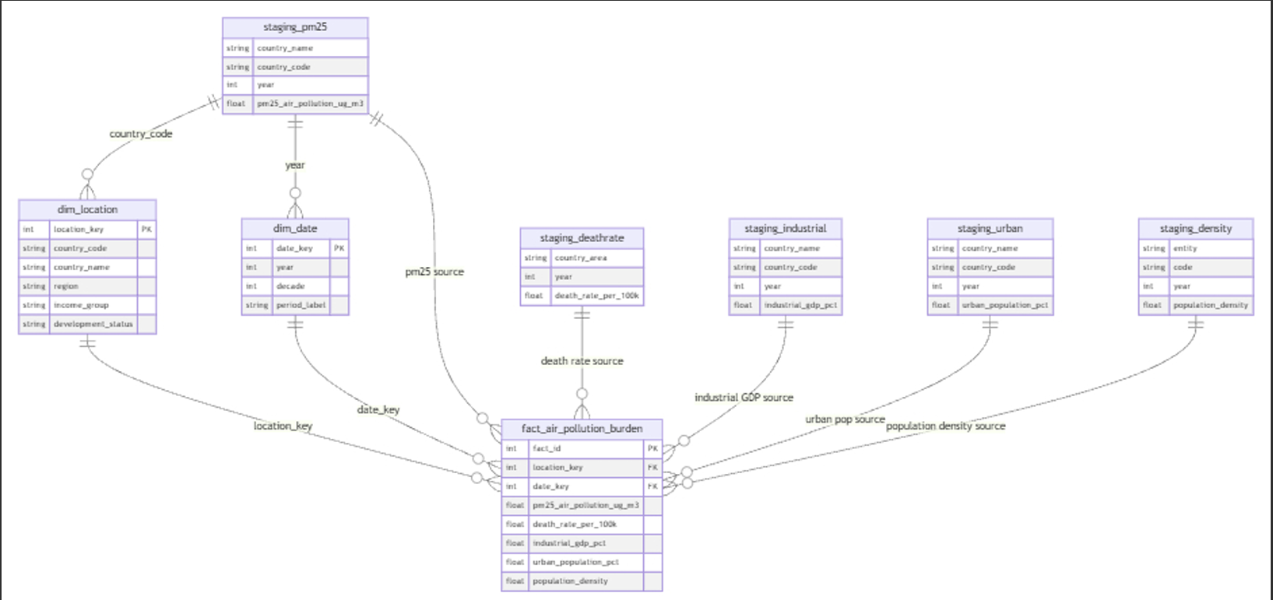
Fig:- ERD Diagram

Data Cleaning and Processing
All cleaning and integration steps are implemented programmatically in the ETL script.
- Data Standardization:
- Column names were standardized to concise, snake_case identifiers:
- "Country Name" → country_name
- "Country Code" → country_code
- "PM2.5 air pollution µg/m³" → pm25_air_pollution_ug_m3, etc.
- Data types were normalized: years as integers; all metrics as NUMERIC.
- Country codes (ISO-3) were used as the canonical key wherever available to ensure consistent joints across datasets.
- Data Merging:
- Each CSV is first loaded into a staging table (e.g., staging.pm25_air_pollution_raw, staging.death_rate_air_pollution_raw, etc.).
- dim_location is built by extracting distinct (country_code, country_name) pairs from the PM2.5 staging table, ensuring a single location record per country.
- The final fact table joins PM2.5 data with industrial GDP, urban population, population density, and death rates using (country_code, year) where possible, and (country_name, year) for the mortality data which lacks codes.

Data Transformation:
Key transformation steps:
- Year dimension mapping: each year is mapped to a date_key in dim_date, where additional attributes (decade, period label) are stored.
- Aggregation level: all measures are kept at country–year grain, which is the natural common level of the source files and supports time-series and cross-sectional analysis.
- Handling missing values: LEFT JOINs are used when populating the fact table so that missing values in any auxiliary dataset (e.g., industrial GDP for some small states) do not drop the entire country–year record; the metric simply remains NULL

Data Validation:
Several validation checks were performed:
- Row counts of staging tables were compared with the number of lines in the CSVs.
- Spot checks ensured that PM2.5, death rate, and other metrics for specific countries (e.g., India, Nigeria) matched the values shown in Tableau after loading.
- Referential integrity is enforced through foreign keys from the fact table to dim_date and dim_location, ensuring no orphaned records.

Data Storage
All data is stored in a PostgreSQL database named air_pollution_dw. The schema design separates:
- staging schema – raw, minimally transformed data directly from CSVs.
- public schema – conformed dimensions (dim_date, dim_location) and the analytical fact table (fact_air_pollution_burden)

4.3-Dimensional Modeling
- Fact Table:
- Grain: one row per country–year.
location_key | Foreign Key → dim_location
date_key | Foreign Key → dim_date
pm25_air_pollution_ug_m3 | annual average PM2.5 (µg/m³)
death_rate_per_100k | deaths per 100,000 attributable to air pollution
industrial_gdp_pct | industrial share of GDP (%)
urban_population_pct | share of population in urban areas (%)
population_density | people per km²

This single fact table is sufficient to answer all five research questions and supports both time-series and cross-sectional analysis. Dimension Tables
dim_date | Attributes: date_key, year, decade, period_label (e.g., “1990s”).  Purpose: enables easy filtering and grouping by year and decade.
dim_location | Attributes: location_key, country_code, country_name, region, income_group, development_status.  Purpose: At present, region, income_group, and development_status are optional fields that can be populated from external lookups; they are already used in the Tableau views for regional and income-group comparisons.
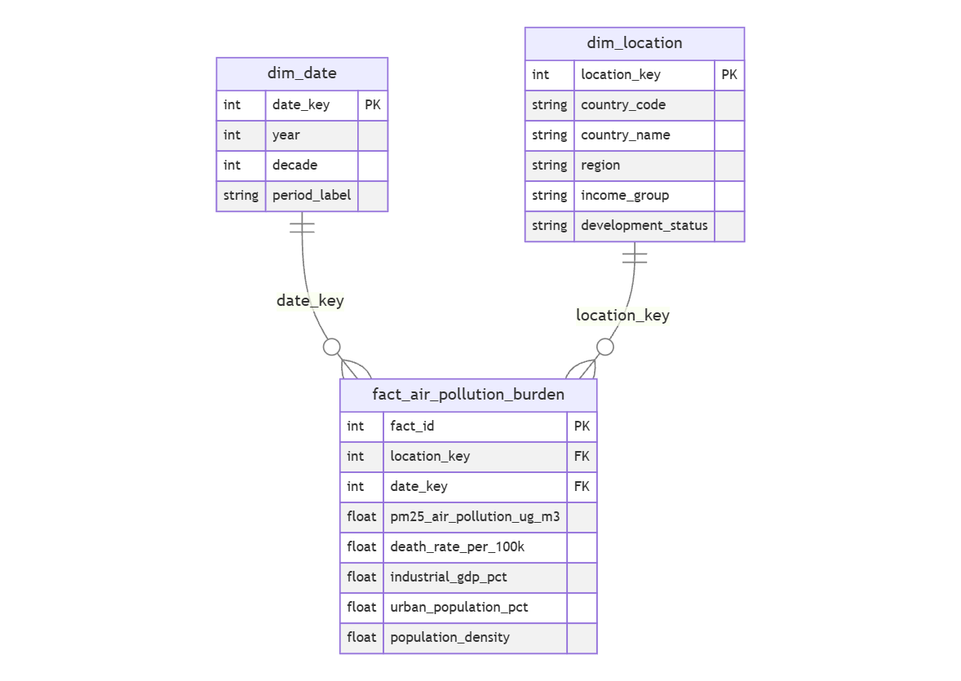

Fig:- Database Schema Diagram
- Architecture Model:
Conceptually, the architecture follows a classic ETL data warehouse pattern:
Layer | Description
Source | CSV files: PM2.5, death rates, urbanization, industrial GDP, population density
Staging | PostgreSQL staging schema with tables mirroring each CSV
Warehouse | PostgreSQL public schema with dim_date, dim_location, fact_air_pollution_burden
Semantic | SQL views exposing analysis-ready datasets (vw_air_pollution_burden, etc.)
Visualization | Tableau dashboards and stories: global maps, trends, scatter plots, comparisons

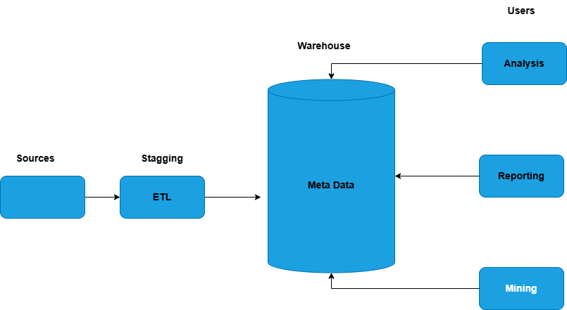
Fig:- ETL Architecture Diagram
  - Create Table Statements
  - Creating the Database
The analytical database for this project is built in PostgreSQL using a Python script (database_creation_python_script.py). This script initially establishes a connection to the default Postgres database. The software then determines whether a database called air_pollution_dw already exists. If not, it executes the CREATE DATABASE air_pollution_dw command.
By automating this phase, the data warehouse can be generated reliably on any system with PostgreSQL installed, eliminating the need to manually perform SQL queries in pgAdmin.
  - Creating Tables and Pushing Data to PostgreSQL
Once the database exists, the same script creates all core data warehouse objects. A separate staging schema is created to hold raw imported data. Within the main schema, three central tables are defined:
- dim_date – the date dimension, containing a surrogate key (date_key), the calendar year, the corresponding decade, and a simple period label (e.g., “2000s”).
- dim_location – the location dimension, containing a surrogate key (location_key), the ISO 3-letter country_code, country_name, and optional attributes such as region, income_group, and development_status.
- fact_air_pollution_burden – the fact table, containing a surrogate fact_id, foreign keys to dim_date and dim_location, and the main measures used in the analysis:
  - PM2.5 concentration (µg/m³),
  - death rate from air pollution per 100,000 people,
  - industrial GDP share (%),
  - urban population share (%),
  - population density (people per km²).
The push_to_postgres_python_script.py script is then responsible for loading the cleaned CSV files into staging tables and populating the dimension and fact tables. This script uses pandas to read the CSVs, performs basic cleaning and renaming of columns, and then pushes the data into PostgreSQL using efficient bulk-load operations.
# database_creation_python_script.py
import psycopg2
from psycopg2.extensions import ISOLATION_LEVEL_AUTOCOMMIT
DB_NAME = "air_pollution_dw"
DB_USER = "postgres"
DB_PASSWORD = "1234"
DB_HOST = "localhost"
DB_PORT = "5432"

def create_database():
conn = psycopg2.connect(
dbname="postgres",
user=DB_USER,
password=DB_PASSWORD,
host=DB_HOST,
port=DB_PORT
)
conn.set_isolation_level(ISOLATION_LEVEL_AUTOCOMMIT)
cur = conn.cursor()

cur.execute(f"SELECT 1 FROM pg_database WHERE datname = %s;", (DB_NAME,))
if cur.fetchone() is None:
cur.execute(f'CREATE DATABASE "{DB_NAME}";')
print(f"Database {DB_NAME} created.")
else:
print(f"Database {DB_NAME} already exists.")
cur.close()
conn.close()

def create_dw_schema_and_tables():
conn = psycopg2.connect(
dbname=DB_NAME,
user=DB_USER,
password=DB_PASSWORD,
host=DB_HOST,
port=DB_PORT
)
cur = conn.cursor()

ddl_statements = """

CREATE SCHEMA IF NOT EXISTS staging;

CREATE TABLE IF NOT EXISTS dim_date (
date_key SERIAL PRIMARY KEY,
year INT UNIQUE NOT NULL,
decade INT,
period_label VARCHAR(50)
);

CREATE TABLE IF NOT EXISTS dim_location (
location_key SERIAL PRIMARY KEY,
country_code VARCHAR(3) UNIQUE NOT NULL,
country_name VARCHAR(200) NOT NULL,
region VARCHAR(100),
income_group VARCHAR(50),
development_status VARCHAR(50)
);

CREATE TABLE IF NOT EXISTS fact_air_pollution_burden (
fact_id BIGSERIAL PRIMARY KEY,
location_key INT NOT NULL REFERENCES dim_location(location_key),
date_key INT NOT NULL REFERENCES dim_date(date_key),

pm25_air_pollution_ug_m3 NUMERIC,
death_rate_per_100k NUMERIC,
industrial_gdp_pct NUMERIC,
urban_population_pct NUMERIC,
population_density NUMERIC
);

CREATE TABLE IF NOT EXISTS staging.pm25_air_pollution_raw (
country_name VARCHAR(200),
country_code VARCHAR(3),
year INT,
pm25_air_pollution_ug_m3 NUMERIC
);

CREATE TABLE IF NOT EXISTS staging.death_rate_air_pollution_raw (
country_area VARCHAR(200),
year INT,
death_rate_per_100k NUMERIC
);

CREATE TABLE IF NOT EXISTS staging.urban_population_raw (
country_name VARCHAR(200),
country_code VARCHAR(3),
year INT,
urban_population_pct NUMERIC
);

CREATE TABLE IF NOT EXISTS staging.industrial_gdp_raw (
country_name VARCHAR(200),
country_code VARCHAR(3),
year INT,
industrial_gdp_pct NUMERIC
);

CREATE TABLE IF NOT EXISTS staging.population_density_raw (
entity VARCHAR(200),
code VARCHAR(3),
year INT,
population_density NUMERIC
);

"""
cur.execute(ddl_statements)
conn.commit()
cur.close()
conn.close()
print("Schemas and tables created.")

def populate_dim_date(start_year=1990, end_year=2030):
conn = psycopg2.connect(
dbname=DB_NAME,
user=DB_USER,
password=DB_PASSWORD,
host=DB_HOST,
port=DB_PORT
)
cur = conn.cursor()

for year in range(start_year, end_year + 1):
decade = (year // 10) * 10
period_label = f"{decade}s"
cur.execute(
"""
INSERT INTO dim_date (year, decade, period_label)
VALUES (%s, %s, %s)
ON CONFLICT (year) DO NOTHING;
""",
(year, decade, period_label)
)

conn.commit()
cur.close()
conn.close()
print("dim_date populated.")

if __name__ == "__main__":
create_database()
create_dw_schema_and_tables()
populate_dim_date(1990, 2025)

Data Warehouse Design and Implementation
This project implements a data warehouse (OLAP) architecture to analyze the global health burden of air pollution. Understanding the fundamental differences between operational databases (OLTP) and analytical databases (OLAP) is essential for appreciating why modern organizations maintain separate systems for transactions and analysis. This section explains these architectural concepts and how they apply to our air pollution data warehouse.

Operational Layer (OLTP):- Real Time Transaction Processing
OLTP (Online Transaction Processing) systems are designed to manage high volumes of real-time transactions with multiple concurrent users. These systems prioritize data integrity, fast write operations, and immediate consistency.
Key Characteristics of OLTP Systems
Handles day-to-day operational data (individual sensor readings, death certificates, transactions)
Optimized for INSERT, UPDATE, and DELETE operations
Highly normalized schema (3NF) to eliminate data redundancy
Stores current, detailed, granular data at the transaction level
Supports thousands of concurrent users performing simple queries
Response time measured in milliseconds
Maintains data integrity through foreign key constraints and ACID properties
OLTP in Air Pollution Context
In a complete air quality monitoring system, an OLTP database would capture:
Individual PM2.5 sensor readings every 5-15 minutes from monitoring stations worldwide
Real-time death certificates with cause-of-death classifications
Daily economic indicators and census updates from government agencies
Metadata about monitoring stations (location, calibration dates, equipment type)
Example operational query: "Record PM2.5 value of 65.3 µg/m³ at Station NYC-001 at 3:45 PM on November 14, 2023"
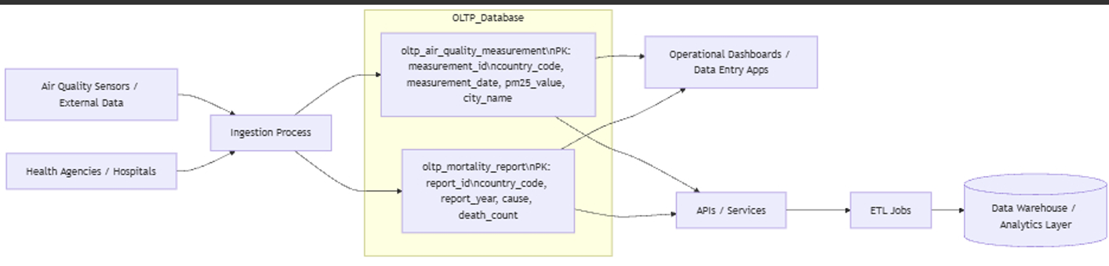

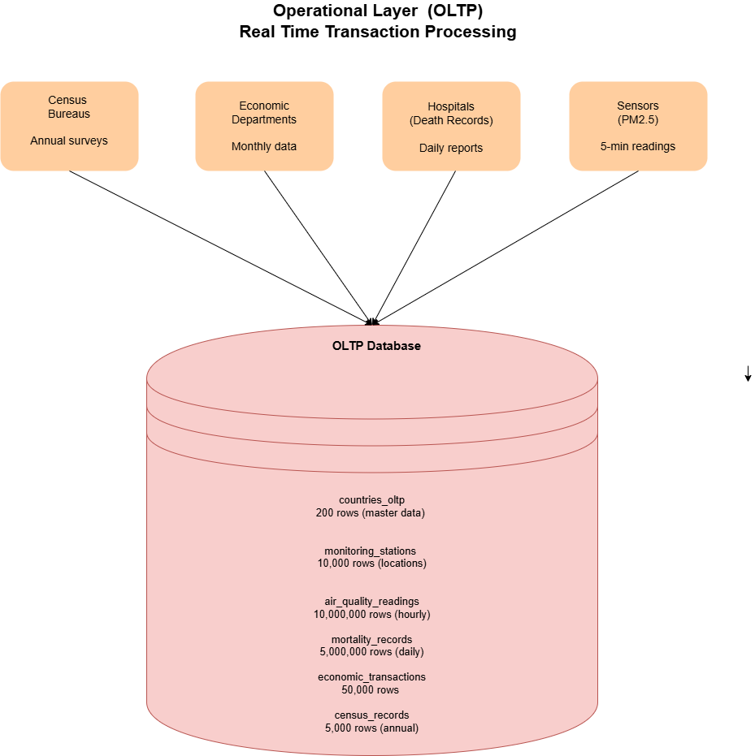

Figure 1: Operational Layer (OLTP) - Real-time data capture from multiple sources

Note: Our project does not implement an OLTP layer. We work with pre-aggregated CSV files at the country-year level, representing the analytical output of such operational systems.

Extract- Transform-Load (ETL)
The Extract-Transform-Load (ETL) pipeline is written in Python, with the psycopg2 module interacting with PostgreSQL and pandas for data management.

Extract:-
During the extraction phase, the script reads each of the five input CSV files PM2.5 concentrations, death rates, urban population, industrial GDP, and population density and converts them into pandas data frames. Immediately after loading, column names are normalized and renamed using a consistent snake_case pattern. This step ensures that the various datasets are easier to combine later.
Transform :-
During transformation, DataFrames are cleaned and aligned to a common key structure based on country_code and year, where possible. Key steps include:
- Converting data types so that years are stored as integers and all indicators (PM2.5, death rate, industrial GDP %, urban population %, population density) are stored as numeric fields.
- Constructing the location dimension (dim_location) by inserting distinct combinations of country_code and country_name derived from the PM2.5 dataset. This provides a single, conformed list of countries.
- Joining all staging tables (PM2.5, death rate, urban population, industrial GDP, and population density) using country_code and year (or country_name where codes are not available) to create a unified dataset at the country–year grain.
The final transformation is implemented as a single SQL INSERT … SELECT statement that reads from all staging tables, joins them on country and year, looks up the corresponding dimension keys (location_key and date_key), and writes the combined results into fact_air_pollution_burden.

Load:
During the load phase, a helper function leverages PostgreSQL's COPY mechanism to bulk-load the DataFrames into the staging tables, which is much faster than inserting each row individually. After populating the staging tables, the converted data is inserted into the fact table in a single batch.
After this ETL procedure is completed, the data warehouse is fully loaded and ready for querying by external tools like Tableau. No manual intervention is required, making the process repeatable and resilient.
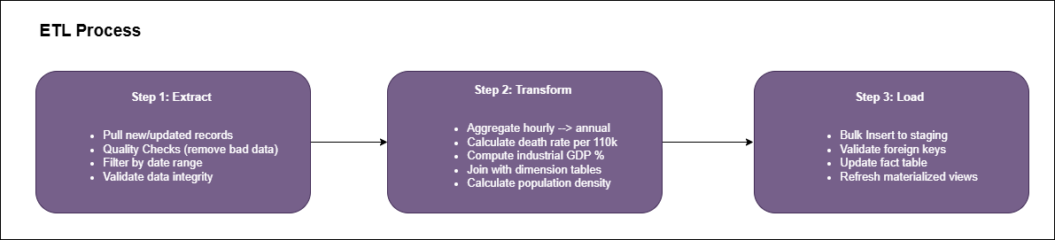
Figure 2: ETL Process - Transforming operational data into analytical insights

Analytical Layer (OLAP): Strategic Decision Support
OLAP (Online Analytical Processing) systems are designed for complex queries, historical analysis, and strategic decision-making. Unlike OLTP systems that handle transactions, OLAP systems support analysts and executives exploring trends, patterns, and correlations.
Key Characteristics of OLAP Systems
- Supports strategic decision-making through historical trend analysis
- Optimized for SELECT queries with complex JOINs and aggregations
- Denormalized schema (star or snowflake) for fast query performance
- Stores aggregated, summarized data at higher levels (country-year, not hourly)
- Serves small number of analysts performing complex analytical queries
- Response time measured in seconds to minutes for complex aggregations
- Read-heavy workload with periodic batch updates

Star Schema Design
Our data warehouse follows the star schema pattern, consisting of:
1. Fact Table (Center of the Star)
- Contains quantitative measures (PM2.5 levels, death rates, GDP percentages)
- Foreign keys link to dimension tables
- Represents the grain of analysis (one row per country-year)
- Stores approximately 5,000 rows (200 countries × 25 years)
2. Dimension Tables (Points of the Star)
- Provide descriptive context for measures (country names, years, regions)
- Support filtering, grouping, and drill-down operations
- Enable hierarchical analysis (year → decade → period)
- Relatively small (40 years, 200 countries)
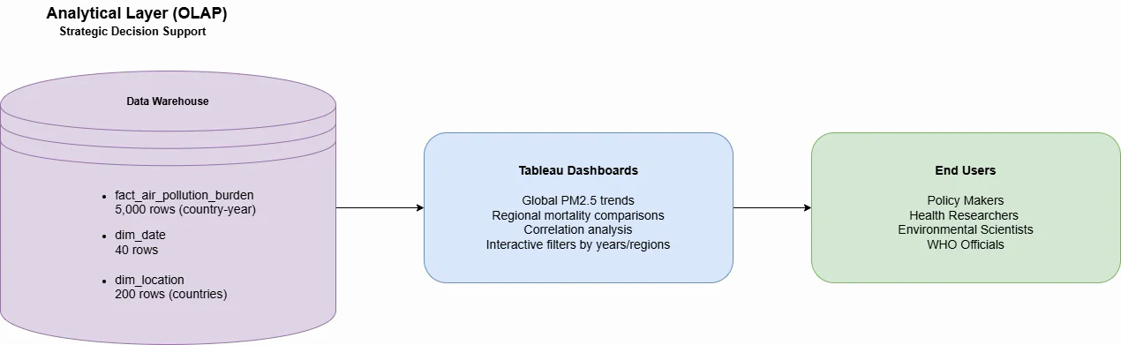
Figure 3: Analytical Layer (OLAP) - Data warehouse connected to business intelligence tools
Benefits of Star Schema
- Simple structure - easy for analysts to understand and query
- Fast query performance - fewer JOINs compared to normalized schemas
- Optimized for business intelligence tools (Tableau, Power BI)
- Supports drill-down and roll-up analysis across dimensions
- Flexibility to add new dimensions without restructuring fact table

OLTP vs OLAP: Comparative Analysis
The following table summarizes the fundamental architectural differences between operational and analytical database systems:
Aspect | OLTP (Operational) | OLAP (Analytical)
Purpose | Handle daily transactions | Support strategic decisions
Users | Many concurrent (1000s) | Few analysts (10-50)
Data Scope | Current, detailed, real-time | Historical, aggregated, summarized
Schema Design | Normalized (3NF, many tables) | Denormalized (Star, few tables)
Data Volume | Millions of rows | Thousands of aggregated rows
Data Grain | Individual event (hourly) | Country-year aggregate (annual)
Update Pattern | Frequent INSERTs (real-time) | Batch loads (daily/weekly ETL)
Query Type | Simple indexed lookups | Complex analytical JOINs
Primary Operations | INSERT/UPDATE/DELETE | SELECT with aggregations
Response Time | Milliseconds | Seconds to minutes
Example Query | Record sensor reading | Analyze 30-year trend
Why Organizations Need Both:
OLTP ensures accurate, real-time transaction processing and data integrity
OLAP enables complex analysis without impacting operational performance
Separation of concerns - each system optimized for its specific workload
ETL process bridges the gap, transforming operational data into analytical insights
Our Project: We implement a pure OLAP system. Our data sources (CSV files from WHO, World Bank, OECD) already represent aggregated annual data, bypassing the need for an operational OLTP database.

Connect Tableau to PostgreSQL
Query for Data Analysis in Tableau
Tableau connects directly to the PostgreSQL data warehouse (air_pollution_dw) using the built-in PostgreSQL connector. After supplying the server, database, username, and password, the user can browse the available schemas and tables.
For analysis, a dedicated view called vw_air_pollution_burden is created in PostgreSQL. This view joins the fact table (fact_air_pollution_burden) with the date and location dimensions (dim_date and dim_location) and exposes a flat, analysis-ready table containing:
- country name and code,
- region, income group, and development status (where available),
- year,
- PM2.5 concentration,
- death rate from air pollution,
- industrial GDP share,
- urban population share,
- population density.
Additional views are created to directly support the research questions, for example:
- a view summarizing global PM2.5 trends over time,
- a view for PM2.5 versus death rate scatter-plot analysis,
- regional comparison views,
- views summarizing relationships with industrial GDP, urbanization, and population density.
Tableau dashboards and stories are then built on top of these views to provide global maps, time-series line graphs, scatter plots, and regional comparison charts without requiring complex joints inside Tableau itself
SELECT
f.fact_id,
TO_DATE(d.year::text, 'YYYY') AS year_date,
dl.country_name,
dl.country_code,
dl.region,
dl.income_group,
dl.development_status,
f.pm25_air_pollution_ug_m3,
f.death_rate_per_100k,
f.industrial_gdp_pct,
f.urban_population_pct,
f.population_density
FROM fact_air_pollution_burden f
JOIN dim_date d
ON f.date_key = d.date_key
JOIN dim_location dl
ON f.location_key = dl.location_key
ORDER BY dl.country_name, year_date;
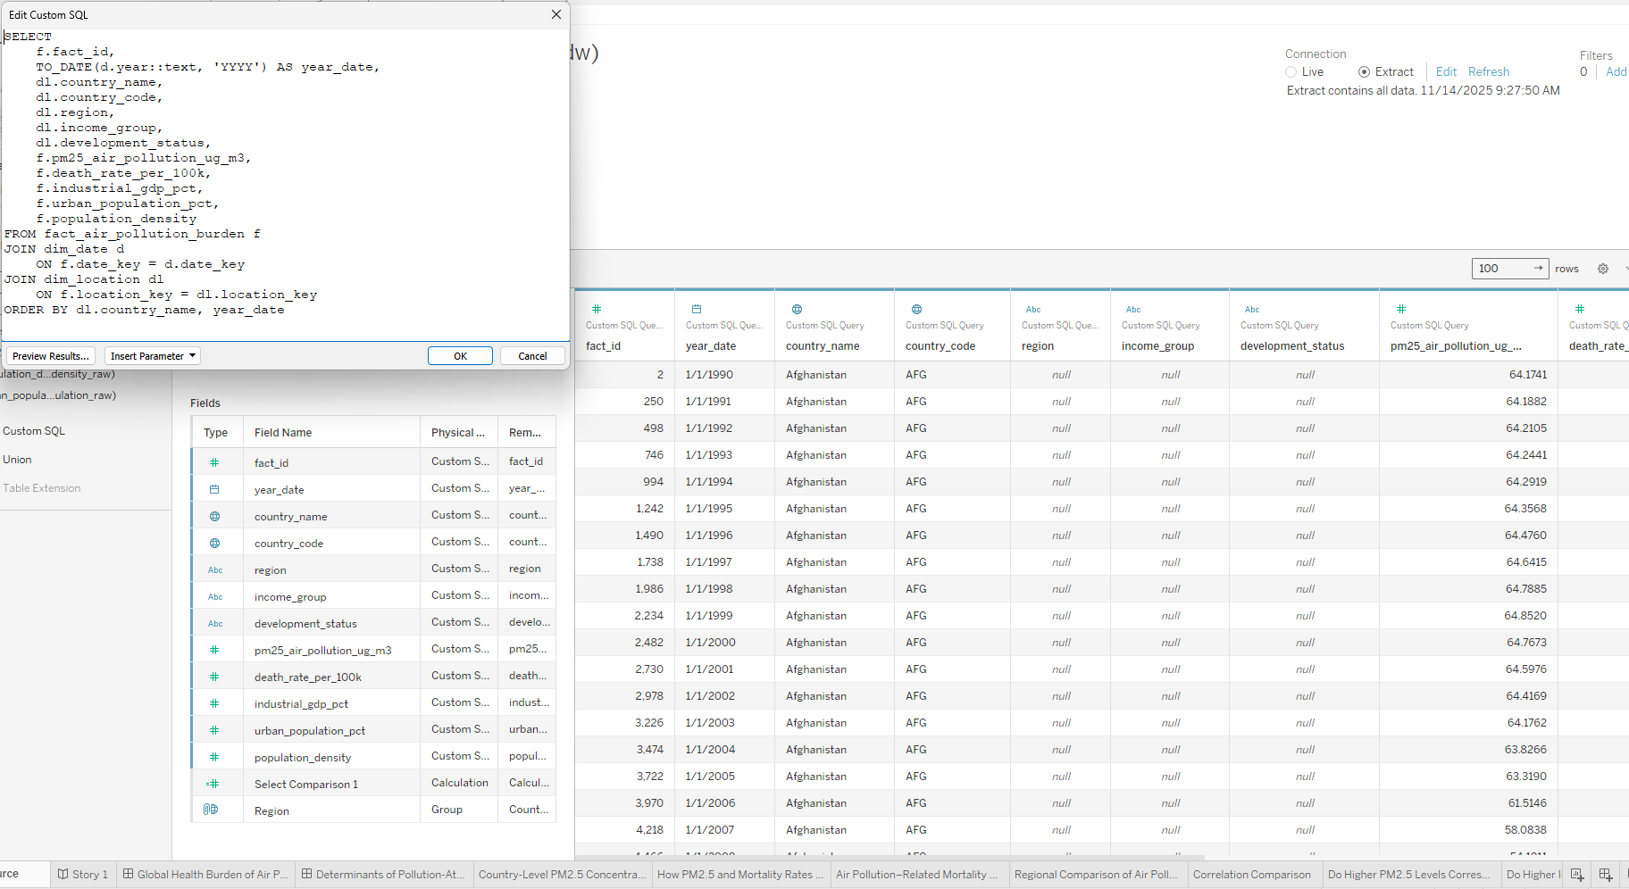

Story Telling - Data Analysis
The dashboards provide a multifaceted view of air pollution and its health consequences. The twelve insights below summarize the significant patterns based on maps, regional comparisons, scatter plots, and time-series graphs.
1: Country-Level PM2.5 Concentrations in 2022
The global PM2.5 map for 2022 reveals a wide range of exposure—from under 4.3 µg/m³ in the cleanest countries to slightly above 50 µg/m³ in the most polluted.
- Nigeria (~54.4 µg/m³) and Chad (~43.9 µg/m³) significantly exceed the WHO limit of 5 µg/m³.
- India (~29.2 µg/m³) and Bangladesh (~25.0 µg/m³) have significantly higher than recommended levels, exposing hundreds of millions of people to harmful air.
- Sub-Saharan Africa and South Asia are on the upper half of the color scale, while Europe, North America, and Oceania are on the lower end (about 12-15 µg/m³).
This snapshot underscores that in 2022, many countries remained exposed to PM2.5 concentrations that are 5–10 times higher than health-based guidelines.

2: Trends in PM2.5 and Mortality Over Time
The time-series panel combining average global PM2.5 and air-pollution-related fatalities per 100,000 people displays two significant patterns:
- Global average PM2.5 concentrations decreased from 40-42 µg/m³ in the mid-1990s and early 2000s to around 25 µg/m³ in 2022. This represents a drop of approximately 35-40% from peak levels.
- Air pollution has significantly reduced global mortality rates, from 185 deaths per 100,000 in the 1990s to 97 deaths per 100,000 in 2022, a 48% decline.
The concurrent drop indicates that advances in air quality, along with better healthcare, cleaner technologies, and regulatory initiatives, have significantly lowered the worldwide mortality load, even though pollution remains above safe levels in many regions.
3: Country-Level Mortality Hotspots
The 2022 mortality map shows that Papua New Guinea (~298 fatalities per 100,000), Guinea-Bissau (~288 per 100,000), and Afghanistan (~281 per 100,000) have the greatest rates of air pollution-related deaths.
• Mortality rates in Central and West Africa, as well as South and Southeast Asia, exceed the global average of 150-200 per 100,000 people.
The regional overlap between high PM2.5 and high mortality highlights the combined effect of severe exposure and low health-care capability.
4: Regional Comparison of PM2.5 and Mortality
The regional bar charts measure how different sections of the world compare.
- Africa has the highest average PM2.5 levels (32.4 µg/m³), resulting in a mortality rate of around 166.8 per 100,000 people.
- Asia has a rate of 26.1 µg/m³ and 117.4 fatalities per 100,000 people.
- Oceania has lower PM2.5 levels (~10.6 µg/m³) but shockingly high mortality rates (~150.2 per 100k), possibly due to high-burden countries like Papua New Guinea.
- Europe had the best combined performance, with PM2.5 levels near 10.7 µg/m³ and mortality rates around 33.1 per 100,000, which is roughly one-fifth of the African average.
This comparison quantitatively highlights the disparity in health outcomes: Africans breathe air that is three times more polluted than Europeans and have a fivefold higher mortality rate.
5: PM2.5 and Mortality by Country – Positive Association
The country-level scatter plot of PM2.5 (x-axis) vs mortality (y-axis) reveals a clear rising trend: greater PM2.5 levels are associated with higher death rates.
- Nigeria has 54.4 µg/m³ PM2.5 and approximately 153.5 deaths per 100,000 people.
- Chad has 43.9 µg/m³ and around 233.8 fatalities per 100,000 people.
- Countries with PM2.5 levels below 10 µg/m³ often have mortality rates below 50 per 100,000.
While there are exceptions, the overall pattern is consistent with epidemiological evidence indicating each incremental rise in PM2.5 significantly increases mortality risk.
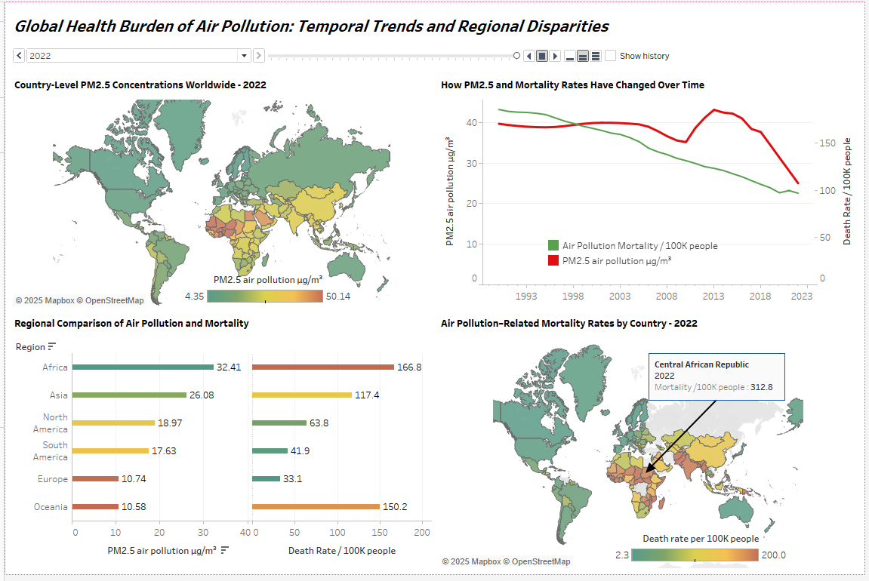
Fig:- Tableau Dashboard - Global Health Burden of Air Pollution: Temporal Trends and Regional Disparities
6: Industrialization and PM2.5 Concentrations
Another scatter plot relates PM2.5 levels to the percentage of GDP derived by industry. Although the relationship is not precisely linear, an overall increasing tendency can be seen:
- Qatar's industry accounts for approximately 65.3% of GDP, with PM2.5 levels around 56.9 µg/m³.
- Saudi Arabia (53.1% industrial GDP) has PM2.5 levels of 44.6 µg/m³.
- In Equatorial Guinea, around 56.2% recorded 38.8 µg/m³.
These examples show how energy-intensive, fossil-fuel-based industrial structures can push countries into high-pollution zones if not balanced by strict emissions limits and better technologies.
7: Urbanization and Mortality – Non-Linear Relationship
The second dashboard shows a scatter plot of urbanization (%) vs death rate per 100,000, with a downward-sloping trend line:
- Even in highly urbanized countries like Bahrain (89.7% urban) and Qatar, mortality rates remain high (about 155.5 and 116.5 fatalities per 100,000 people, respectively).
- Other nations with urbanization above 70-80%, such as Europe and North America, have death rates below 80 per 100,000 people.
The overall trend indicates that, at a certain point, higher urbanization is connected with decreased mortality most likely because dense metropolitan regions can invest in modern energy, healthcare, and pollution management. However, where urban growth outpaces regulation, mortality remains high despite large urban populations.

8: Population Density and Risk Exposure
Visual filters that focus on densely populated regions show how crowding magnifies exposure:
- India and Bangladesh have high population densities and PM2.5 values of 25-30 µg/m³, leading to higher mortality rates.
- In comparison, sparsely populated countries like Canada have far lower death rates (about 5 deaths per 100,000), indicating better pollution control and lower concentration hotspots.
This implies that in highly populated areas, even minor increases in PM2.5 can result in a substantial absolute number of deaths.

9: Industrial GDP Share and Mortality
A scatter plot shows that Pakistan, whose industry accounts for 20.4% of GDP, has a death rate of approximately 206.9 per 100,000 people.
- Nigeria, with a 30.8% industrial GDP, has a high death rate (about 153.5 per 100,000).
These instances demonstrate how industrial expansion in the absence of strong emission restrictions can considerably raise the health burden.

10: Urbanization vs. Death Rate – Correlation Pattern
The correlation panel in the second dashboard (urbanization versus mortality rate) supports a moderate negative association: as the proportion of the urban population increases, death rates tend to reduce. Many countries have 60-80% urbanization and death rates of less than 100 per 100,000 people, indicating that access to cleaner fuels, regulated businesses, and improved medical facilities helps to mitigate pollution hazards.
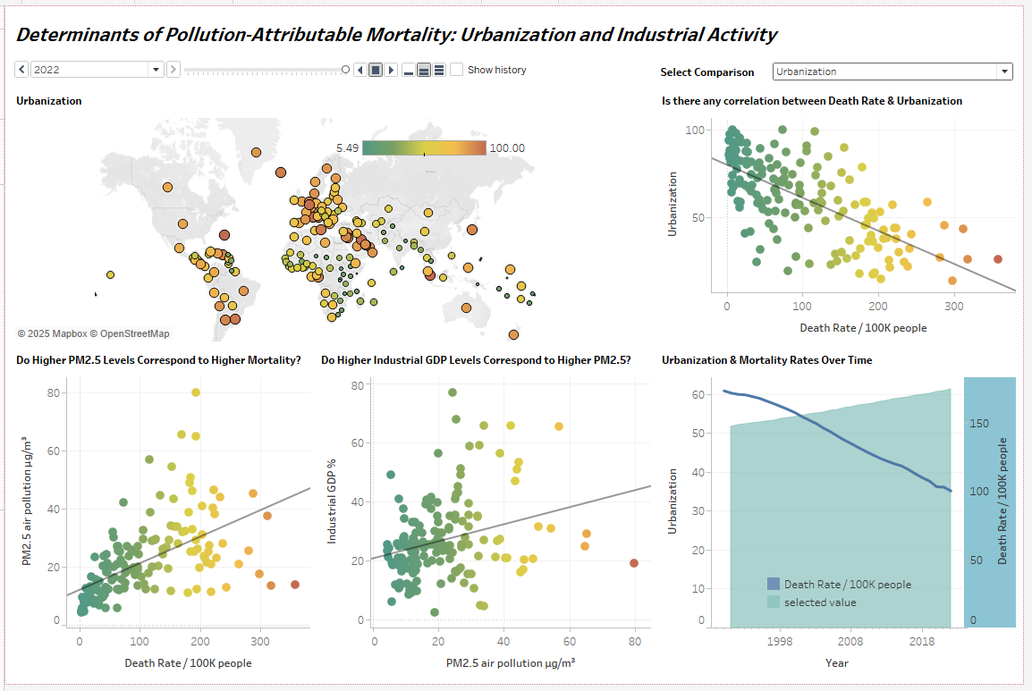
Fig: Tableau Dashboard - Determinants of Pollution-Attributable Mortality: Urbanization and Industrial Activity
11: PM2.5 vs. Death Rate – Strengthening the Causal Narrative
When PM2.5 levels approach 15 µg/m³, mortality rates slowly increase, as seen by the combined scatter of PM2.5 vs death rate with a fitted regression line. Countries below this threshold seldom surpass 80 deaths per 100,000, but those above 30-40 µg/m³ sometimes exceed 150 per 100,000. This visually supports the epidemiological concept of a dose-response relationship.
12: Urbanization and Mortality Over Time
The time-series chart of average urbanization vs global mortality offers a striking contrast:
- Urbanization rises from roughly the low-50% range in the late 1990s to around 60% in recent years.
- Over the same period, death rates from air pollution decline from well above 150 per 100k to under 100 per 100k.
This indicates that, globally, the world is becoming more urban and yet experiencing fewer pollution-attributable deaths per capita—likely due to cleaner technologies, regulation, and improved healthcare systems in many urban centers, even as pollution remains severe in specific hotspots.

Key Findings
- Global reductions but unsafe levels – Both PM2.5 concentrations and air-pollution-related mortality have fallen substantially over the past three decades, but in many countries current PM2.5 levels still exceed recommended health guidelines by several times.
- Strong link between exposure and mortality – There is a clear positive association between PM2.5 levels and death rates, supporting the scientific evidence of a dose–response relationship.
- Marked regional disparities – Africa and parts of Asia bear a disproportionate share of the global health burden, whereas Europe and North America exhibit lower exposure and far lower mortality.
- Role of industrialization and density – High industrial GDP shares and extreme population densities tend to amplify risks, particularly where environmental regulation and technological controls are limited.
- Urbanization is context-dependent – Urbanization is not inherently harmful; in well-regulated, high-income settings it can coexist with declining mortality, suggesting that policy and infrastructure are crucial.

Conclusion
The project demonstrates how a structured data-warehouse strategy can provide a comprehensive, multidimensional view of the worldwide health impact of air pollution. By integrating different datasets into a PostgreSQL star schema and presenting them in Tableau, we can investigate long-term trends, regional disparities, and important causes of pollution-related mortality in a consistent and transparent manner.
The examination focuses on both progress and lingering obstacles. While average PM2.5 levels and associated mortality have decreased, several countries continue to exceed health-related limits. Thus, air pollution remains a serious public-health and development issue, especially in areas where industrial growth and urbanization exceed regulatory capacity and technological improvement.

Next Steps and Recommendations
- Enrich the dimensional model
Fill in additional attributes in dim_location, such as region, income group, and development status, with authoritative external metadata (e.g., World Bank country classifications), to allow for more detailed stratified analysis.
- Expand indicator coverage
To acquire a holistic view of air quality and health, include additional contaminants (e.g., NO₂, O₃), energy and fuel-mix indicators, and cause-specific health effects.
- Increase spatial and temporal resolution
Expand the data warehouse to include sub-national (city-level) indicators and higher-frequency measurements (monthly or seasonal averages) to better capture local occurrences and policy consequences.
- Apply advanced analytical methods
Use the data warehouse to build statistical or machine-learning models that measure the marginal impacts of PM2.5, urbanization, and industrial structure on mortality.
- Develop policy simulation tools
Create interactive Tableau dashboards that may simulate "what-if" scenarios (for example, reducing PM2.5 in a certain country by a set amount) to demonstrate the possible health benefits of proposed measures.

References
- Our World in Data. (n.d.). Air pollution & mortality dataset. https://ourworldindata.org/air-pollution
- World Bank. (n.d.). Urban population (% of total population). https://data.worldbank.org/indicator/SP.URB.TOTL.IN.ZS
- World Bank. (n.d.). Population, total. https://data.worldbank.org/indicator/SP.POP.TOTL
- OECD. (n.d.). Air pollution exposure (PM2.5). https://www.oecd.org/en/data/indicators/air-pollution-exposure.html
- World Health Organization. (n.d.). Global Health Observatory: Air pollution mortality data. https://www.who.int/data/gho/data/themes/air-pollution

